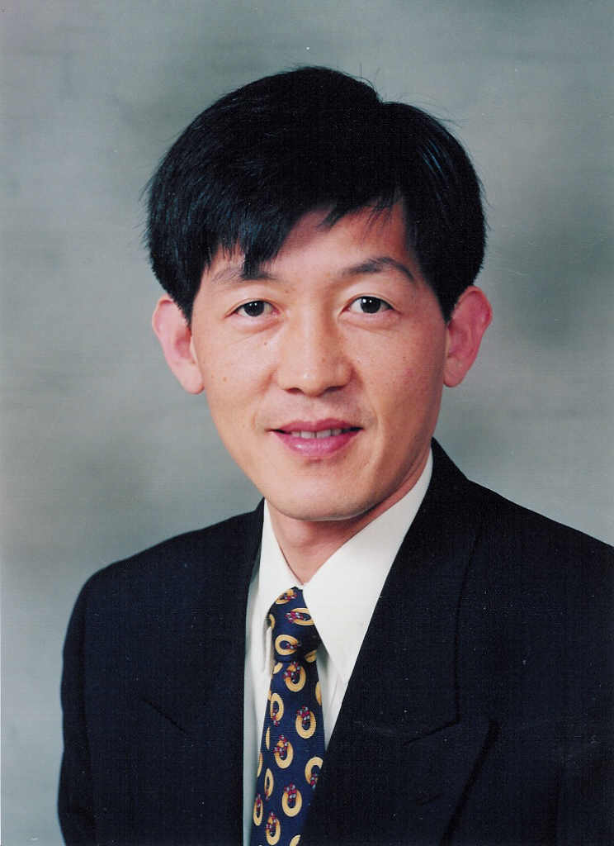
Chong Nam Chu

School of Mechanical & Aerospace Eng.
Seoul National University
Seoul, 151-742, Korea

Phone: +82-2-880-7136
FAX: +82-2-875-2674
E-mail: cnchu@ snu.ac.kr

Research Interest

Precision Machining, Micro-machining, Computer Aided Manufacturing

Education

Ph.D., Massachusetts Institute of Technology, Cambridge, MA, U.S.A., Mechanical Engineering, August 1986.
M.S., Massachusetts Institute of Technology, Cambridge, MA, U.S.A., Mechanical Engineering, June 1982.
B.S., Seoul National University, Seoul, Korea, Mechanical Engineering, February 1979.

Experience

Assistant and Associate Professor, School of Industrial Engineering, Purdue University, W. Lafayette, IN, U.S.A, August 1986 - January 1992.
Registered Professional Engineer, Indiana, U.S.A. ENE8900276, January 1989 – Present.
Visiting Scientist, The Institute of Physical and Chemical Research, and Institute of Industrial Science, The University of Tokyo, Tokyo, Japan, May 1990 - July 1990,.
Professor, School of Mechanical & Aerospace Eng., Seoul National University, Seoul, Korea, February 1992 – Present.

Professional Activity

Associate Editor, Journal of the Korean Society of Precision Engineering, 1993-1999.
Director, Machine Fabrication Center, Seoul National University, 1995-2002.
Director, Fine Instrumentation Center, Seoul National University, 1995-2002.
Vice President, Korea University Industrial Technology Force, 1998 - 2000.
Head, Ultra-precision Engineering Division, Institute of Advanced Machinery and Design, Seoul National University, 1999 - Present.
Director, National Research Center on Micro-machining and Precision Metrology Technology, Seoul National University, 1999 - 2004.
Department Head, School of Mechanical and Aerospace Engineering, Seoul National University, 1999 - 2000.
Associate Director, Advanced Industrial Technology Program, Seoul National University, 2001 - 2002.
Director, Micro-machining Division, Korean Society of Precision Engineering, 2002 - 2003.
Associate Dean, Planning Office, College of Engineering, Seoul National University, 2002 – 2004.
President, Design & Manufacturing Division, KSME, 2006.
Executive Director (Dean), Seoul National University Foundation, 2006 - Present.

